WHY WORK AT SUMMER CAMP?
“This was the best summer of my life”
“Working at Kirchenwald was the best job I ever had”
“I didn’t know anyone going in to it and now all my best friends are from camp”
“It feels so good to make a difference in people’s lives”

So, you’re thinking about a job as a summer camp counselor. Wonderful! Kirchenwald is in need of faithful and mature men and women like you to build our Christian community in the woods. The work is challenging, but incredibly rewarding. Look over these pages to learn more about how you can join our outdoor ministry team and help children grow in their faith, build confidence, and share in fellowship and learning with one another. Also, visit our website: www.lutherancamping.org/kirchenwald for more information.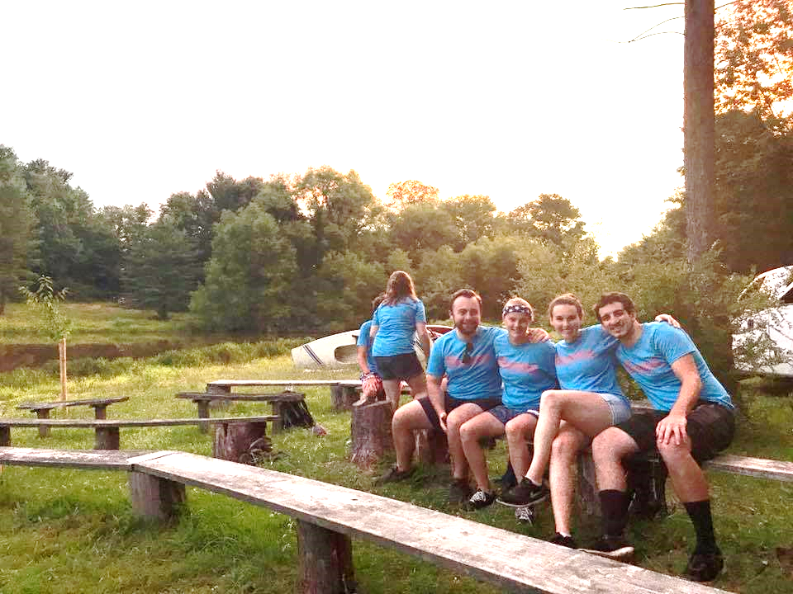

Thanks and peace,

Zach Weiss
Director

What’s working at Kirchenwald like?
Counselors work together in the small group model of camping to shape the week’s experiences for their family-style group of campers. Days include a morning watch, evening devotion, Bible study, nature study, and lots of active recreation. Each program has a unique theme that engages campers and staff in a one-of-a-kind adventure, acting as a conduit for the faith education.

What’s the time commitment?
A typical week starts on Sunday afternoon and concludes on Saturday morning. Staff are provided housing and stay on site with campers during the week. The 2019 season starts with staff training on June 2 and lasts for two weeks. The last day of camper program is August 10. Staff are expected to work the entire summer with as few absences as possible.

But I’m not Lutheran.
While Kirchenwald is affiliated with the ELCA (Lutheran) church, our core values are widely accepted by all Christian faiths. You do not have to be Lutheran to work at camp. It is important, however, that you model the love and acceptance of all people that Jesus demonstrated in his ministry, and that you not disparage the Lutheran tradition or otherwise encourage campers to seek out other denominations.

What are the benefits of working at Kirchenwald?
Job satisfaction: Camp isn’t all fun and games. Working with children can be demanding. But the rewards are great- a camper’s appreciative smile, a parent’s thank you for helping their child grow, the satisfaction of knowing you’ve done something that helped someone else, and the chance to serve God in an outdoor ministry setting.
Fun: If you love being in the outdoors, being with children, camping, swimming, boating, hiking, rock climbing, arts & crafts, singing, and sports, then you will get paid to have fun this summer.
Job experience: Working as a counselor at camp looks great on a resume and gives you valuable skills for almost any career path. You’ll hone your leadership skills and learn how to collaborate with coworkers on a daily basis. Counselors are encouraged to be creative and take initiative. Job recruiters tell us all the time that camp counselors are regularly the most highly rated positions in preparing someone for their future career.
Friends: Friendships formed at camp can be some of the deepest and most long-lasting friendships you will ever have. Your fellow staff members will share many of your values, including a commitment to a Christian lifestyle.
Training: Camp will provide certification in First Aid, CPR, and Lifeguarding for free. Additionally, you will be trained in team building, behavior management, rock climbing, boating, and much more.

What’s the pay?
Working at camp is not the job to make big bucks fast, but it’s wrong to think compensation is not comparable to other jobs when you include all relevant factors. If you’re thinking, “I won’t make enough money this summer if I work at camp,” consider the table below.
Job type | Camp Counselor | $10/hour job | $7.25/hour (min wage)
Income per week | $230 | $400 | $290
After 15% withholdings | $195 | $340 | $246
Cost to travel to work | $0 | $25 | $25
Food costs at home | $0 | $20 | $20
Going out (1x per week) | $0 | $20 | $20
Weekend fun | $20 | $20 | $20
Rent (shared w/ roommates) | $0 | $60 | $60
Utilities (shared) | $0 | $25 | $25
Net income at the end of the summer (10 weeks) | $1750 | $1700 | $760
*These calculations are averages and assume a job 5 miles from your home.
Even if you’re living at home, and are not responsible for food or rent/utilities, your family is still incurring that cost. Camp is the ONLY example where food and lodging is included!

